**Roll No : - 82**

**Name :- PATIL LEENA ARUN**

**Assignment No :- 1.1**

**Assignment :- Develop a program to understand the control statements of Python.**

**(Conditional Statement)**

* **If Statement : -**

a = int(input(**"Enter 1st Number: "**))  
 b = int(input(**"Enter 2nd Number: "**))  
  
 **if** a>b:  
 print(a,**"is greater than, b"**)

* **Output :-**

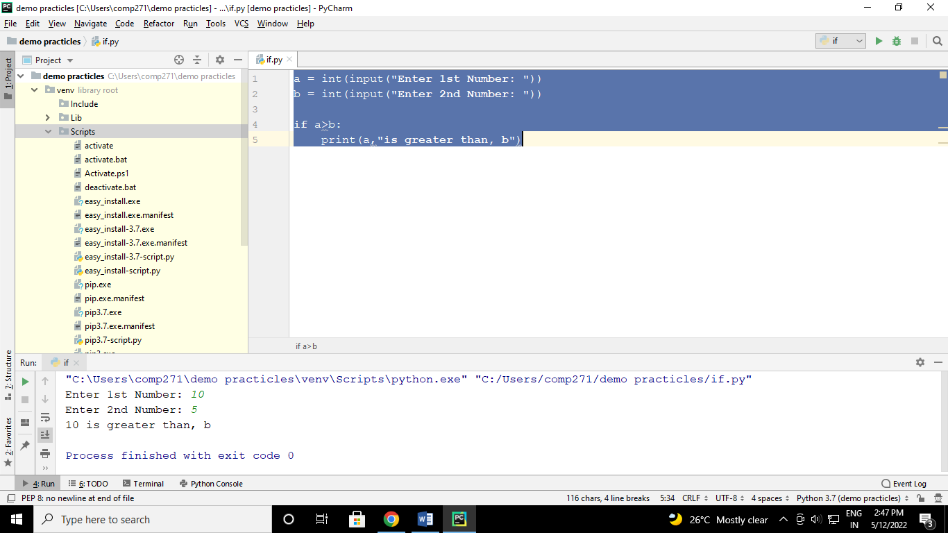

* **If…else Statement : -**

a = int(input(**"Enter 1st Number: "**))  
 b = int(input(**"Enter 2nd Number: "**))  
  
 **if** a>b:  
 print(a, **"is greater than "**, b)  
 **else** :  
 print(a, **"is not greater than "**, b)

* **Output :-**

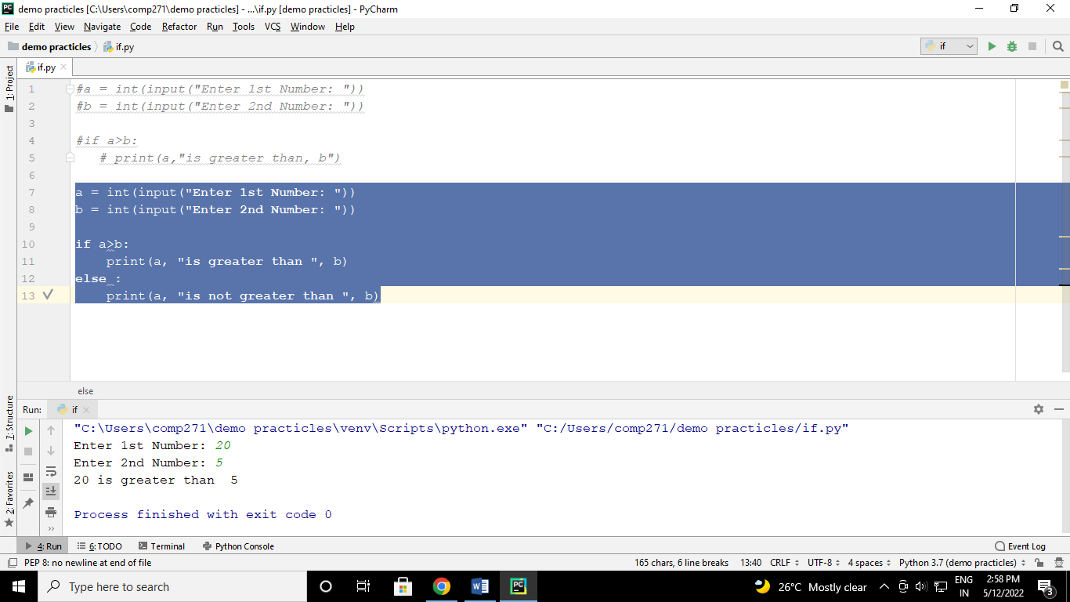

* **Elif Statement :**

a = int(input(**"Enter 1st Number : "**))  
 b = int(input(**"Enter 2nd Number : "**))

**if** a > b:  
 print(a, **"is greater than "**, b)  
 **elif** a < b:  
 print(a, **"is less than "**, b)  
 **else**:  
 print(**"Both are equal"**)

* **Output :-**

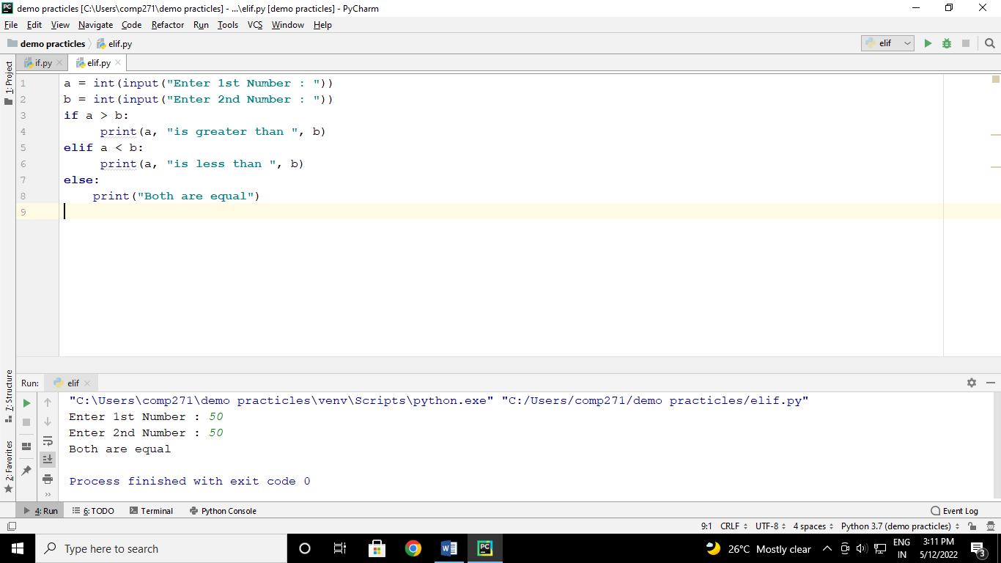

* **Nested if-statement :**

a = int(input(**"Enter any number :-"**))  
 **if** a >= 0:  
 **if** a == 0:  
 print(**"Zero"**)  
 **else**:  
 print(**"Positive number"**)  
 **else**:  
 print(**"Negative number"**)

* **Output :**

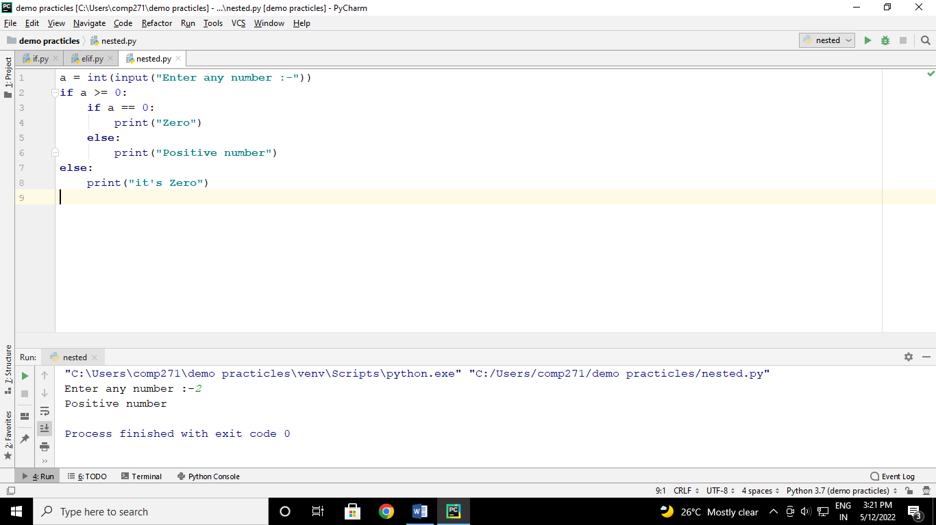

* **Ladder if…else :**

Marks = float(input(**"Enter the marks of Student : "**))  
  
**if** Marks > 85:  
 print(**"The Grade of Student is A+"**)  
**elif** Marks > 75:  
 print(**"The Grade of Student is A"**)  
**elif** Marks > 65:  
 print(**"The Grade of Student is B+"**)  
**elif** Marks > 55:  
 print(**"The Grade of Student is C"**)  
**elif** Marks > 45:  
 print(**"The Grade of Student is D"**)  
**elif** Marks > 35:  
 print(**"The Grade of Student is P"**)  
**else**:  
 print(**"The Grade of Student is F"**)

* **Output :**

